Industrial Project SVSH1: Spec version 17 American version

SOUCOUPE VOLANTE SPATIALE HEYDEN

1. Societies Co-occupiers for the whole parts, components

2. Propulsion engineers calculations

3. Main view and structure chosen

4. Operational performances

5. First study of complete security

6. Environnement Conditions : réf Petit Atlas de Science Moderne

7. Environmental pollution

8. Piloting of this spaceship

Addressees: -For the construction: See Societies Co-occupiers
- For the finance and the budget : TBD

Co-inventors: Roels Anne-Lise, Ir civil
Heyden Eddy, Ir civil
1) Societies Co-occupiers and sub-builder for the whole parts
1. XCOR Aerospace: USA : co-occupier
2. Rusal: Russia : co-occupier
3. MMP and Thalès : France : co-occupiers

4.University of Lotnictwa : sub-builder
5. Option : Siemens-AEG : Germany : co-occupiers

Time of functioning of such a vehicle: 30 years
With components replacement :TBD
Parts with no maintainability estimated, for the industrials societies:
For all parts :
except cockpit main equipments and the liquid air production equipment which have a correct isolation in the air

water complete isolation and hermeticity of the electrical parts

- Component « 1 » : Structure recovered with construction of piloting cel :
. 700000$
Rusal =>in aluminium with profiles in rectangular tubes (800 kg x 1.25) for
The main structure and rectangular complete profiles (200kg x 1.25)
For the support of engines, equipments and piloting cell
=>external paintings in blue sky on the recovered structure
(100 kg x 1.25)
=>Complete space tight for the piloting cell
=>Watertight for the structure(down soldering and up rived with
Silicon more) (whole spaceship)
=>See preliminary drawing and design
=>Glass on the front of the vehicle with electrical de-icing (max
10 kw)
(120 kg x 1.25High Resistance glass)
=>pressurised and tight cel,
2 tanks (1000 dm3 et 20 bars max)with exterior ambiant
Main upper access with a ladder (32 kg structure
And 25 kg of Equipment)
=>Standard fixing of the equipments with bolts ISO
=>exterior recovered with tight position lamps (internal
Mounting)
=>Thermal isolation thermique of the piloting cell
=>10 thermocouples for mesuring temperature of the structure
=>4 fixed landing gear (ground and water)
With spring with stiffness and course
((12000 kgf’/4)*20/0.5 m)
With damper adapted by the constructor (20 g)
=>mass estimated : 1340 kg x 1.25 maximum
=>2 structural little possible fixing (10 kgf force) on the profile
structure with each one 4 fixing points, on the upper side on near the cockpit and the engines fixing and the other on the central part beside the main personal ladder
=>blue painting

=>structural possible fixing (4 T” maximum) of external reserve
of water or combustible or pure metal) weight of
2 x 2 m3 with hydro(aero too)dynamic design
In the lateral down part of the vehicle upside the see landing gear
=>4 fixing possible attach in each upper corner for ground
transportation by external transportation equipment
=>paracute fixing and positioning in the upper par of the vehicle afterward the cockpit and the Russian liq.air Eqt

2) Component « 2 »: Suppressed

3) Component « 3 » : 8 propulsion engines with double combustion chambers : 2700000$ l.u.s. 16 x 168750$ per combustion chamber with all accessories
[Chemestry optimised in mechanical-chemestry through low
Exhaust speedgasses]
XCOR Aerospace
For each of propulsion engine
Nominal propulsion force 6000 lbf thrust : 9 V cmd
[Esti.Maximum propulsion force in security phase 12000 lbf thrust 24 V cmd]
[Exhaust estimated speed in nominal: 0.8 m/s]

Consumption of liquid air: 0.25 kg/sec
Estimated Consumption of fuel in nom/ regul/: 0.01571/4[= 0.25 * 1/15.91/4]
T maximum nominal : 656 °C
Material Combustion Chamber : Molybdene
Support to main structure : Composite material
Estimated mas 8 x 120 kg: 960kg

Slower : 300 lbf

Regulated precision nominal thrust: 24 lbf for the calculator

Perpendicular surface 1 chamber = 0.12 m2 (FI chamber = 400 mm)
P inj = 8 bars

[F = DP * S => DP = 15000 /0.12 =125000 N/m2 = 1.25 bar]

Electrical alimentation 1 set of pump (24 V continuous, max power 0.3 kW
And 9 V continuous, nom. Power 0.1kW )
In flight relighting with THERMAL candle up to the space

16 photoresistances for cockpit from 8 forward and reverse engines : Security
16 photoresistances for cockpit from 8 lifting engines : comfort and security

If possible relighting of engines possible in specific ambient

4) Component « 4 »: Tank of Hexane: 0.7 m3 x 1.25 (approx. 550 kg x 1.25 ) : 8000 $
MMP possible dismounting with level indicator
P ambiant 1.013 bars
Valve open/closed with electricity 24V at the bottom side
System of thermal unfireable isolation (thickness ~ 200 mm)
Alimentation opening standardised with cap
Tank tight with Thickness 3 mm
Mass empty : 34 kg x 1.25
Counter pressure internal cap with Helium at 2 bars
Red painting
Support with silent blocks and composite for thermal insulation
Valves leaks derived to an tight little area

With one electrical pump 24 V with bypass for one alimentation
Circuit (flow and power see engines)

5) Component « 5 » : Suppressed

6) Component « 6 » : Tank of cold liquir air (5) : 5.3 m3 x 1.25 according to autocad : 5 x 5000$ for MMP
Rusal with price comprised in the structure
possible dismounting with level indicator
Objective full (12720 kg)
P tank < 1.013 bar and T° cold regulated tank
System of thermal unfireable isolation (thickness ~ 200 mm)
Russian systeme of cooling and maintain T°cold-200°c=73K
T° hot : structure -50°c->108°c
Power of cooling tank: 9 KW
Valve open/closed with electricity 24V: at the bottom side for engine
Alimentation of liquid air
Alimentation opening standardised for liquid air
Over pression valve: 2 bars
Masse empty (with Russian cooling system): 210 (+25) kg x1.25
Counter pressure internal cap with Helium at 2 bars
Red painting
1 security equipment through thermal measurement Support with silent blocks and composite for thermal insulation

With one electrical pump 24 V with bypass for one alimentation
Circuit (flow and power see engines)

7)Component « 7 » : Manual flight command through electricity low voltage: 20000$ Thalès
Output to engines : with only potentiometric design
Lift propulsion : 4 x 9V with linear command for regulation
( MMP)
Direction propulsion : 2 x ( 9V) and 2 x + 0,3V
Go/back rotation
(Thales for MMP)
( Later Secondary throttle for yaw and pitch 2 x 9 V)
Total redundancy with compatibility 24V for lifting
(Old Inside construction with 5 V (see design preliminary...))
With connection to the cockpit fuses for each engine from XCOR
With total electricity design from Thales for MMP
Force necessary to actionnate command
Maxi : 4 kgf’ whole course
Regulated by the pilot in the cockpit
force to begin movement from 100 gf’ to 1kgf’
(norm. 300 gf’)

Estimated mass: 20 kg

8)Component « 8 » : Cel pressurisation :100000$
(and little reversable frigo réversible : cold and
hot permutable sources (cel and structure),T°max-min theoritical -50°c and
+100°c, power 5 kw) through electricity and air tank
+electrical alimentation (voltage 24 V, power engines 5 kw
See 10)component
+ power liquid air production 1500 kw from a turboprop
Rusal l estimated mass : 40 kg + turboprop 1st estimated 350 kg

9)Component « 9 » : All other equipments (see hereafter):
MMP and a)parachute of 100 m2 (ignifuge) with hyperstucture of steel
Thalès Cables with 4 steel cables 35000$
b)lamps:2000$ (6 x 100 W (white,w,w,w,green,red))(Thalès)
c)4 x electricity batteries of 0-12V continuous 11800$ (Thalès)
(travail unitaire 700 Ah, 300 Amaxi)
(electrodes plomb(Pb), molybdène (Mo)?ou acier inoxydable 0V
With H2SO4 at 1 ? % in pure water (H2O)
d)visualisation engines panel: 2000$
e)thermal structure visualisation panel 1000$
f)GPS standard ground :1000$ (Thalès)
g)électro-magnetic altimeter 5000$ (Thalès)
( approx.2 GHz) altimeter through a preferably ITALIAN radar
h)classique natural horizon 3000$ (Thalès)
with two V outlets : -4.5 v ->4.5v(sea after)
i)classic natural compass 3000$ (Thalès)
with V outlet : -4.5 v ->4.5v(Sea after)

j)pressure altimeter :5000$ (Thalès)
with 0m altitude regulated from 0.0 bar to 2.0 bar
k)pressure vertical speed :3000$ (Thalès)
l)preferably GERMAN Radios : standard FM and
international civil aviation frequences :5000$
m)Connectables radio antens: mass, standard vertical anten,
directionnal parabole of fi 0.18 m like goniometer : 2500$
n)pressure and temperature of the cel: 2500$
o)preferably GERMAN pitots (p dyn and p stat) with
electronic measurement of advance, lateral and vertical
moves for security officer: 3500$
p)fuel and liquid air level measurement :5000$ (Thalès)
q)sensor p exterior, T exterior:3000$ (Thalès)
r)inertial central for space : 15000$ (Garmin GTN 650)(Thalès)
s)AMERICAN computer of sequential piloting 1500$
t)BELGIAN electronic interfaces to engines : See piloting
:2500$
u) others to complete global integrity of the complete vehicle
comprising -security electrical alimentation of rescue 24 V with
alternator in the cockpit (15 kw? maxi) (Thalès)
-normal alimentation 4 batteries of 12V with
Redundancies (Thalès)
-security electrical switches (valise rouge) for
Thrust (Thalès)
-28 electrical valves for redundancy of cold air and fuel alimentation (Thalès)
With connections with tubes (Thalès and MMP) : (35000 $)
v)Electro-mechanical compass and horizon with electrical
outlets (n V) and alimentation 0->24 V if possible
(3000 $) (Thalès)
u) 3 personal standard air reserve (1 hour) in the cockpit
(1000 $)

10)Component « 10 » : Positioning of a possible global dismounted equipment on the upper part of the vehicle after the cockpit which is
an on-line liquid air production at -200 °C 250000$
Rusal frigorific power 500 kw for a flow 2 kg/s
Masse approximative estimated in preliminary 1200 kg

11) Component 11 : 14 orbital little propellers with incorporated fuels and with
University “spaces balises” (2 Satellites ways Galileo minimum)
Lotnictwa mode 1 : Automatic command card with 6 entries from “spaces
balises” ??horizon and compass earth??
??impossible through ionosphere science??
mode 2 : Joystick 1 for angles main pitch,yaw other roll
, Joystick 2 for translations main lift,forward-reverse
Other gliding

Thrust of each propeller 10 kgf’
Regulation with automatic stop at the right speed and
rotation angle

500000$ total with TVA
12) Component 12 : Electronical command card (internal main loop : 0.2 sec)
with supervised by a computer
completed with one screen with a command mouse
and one screen (pilot control)
Ge.El.Co.Un.“spaces balises” (approximate like base Brussels stib bus)
Actual American system
and Galileo in option
with 6 outlets : x°,y°,z^{m},cap°,pente°,speed^{m/s}
Mode 0 : Sequential command in C according to Delphi program
mode 1 : Automatic command card with 6 entries up to “spaces
OPTION SIEMENS-AEG balises” (entry delay 0.1 sec up to ECmd)
mode 2 : Supervisor of engines commands with the computer RS 232
outlets : 16 connections with 9 V to the engines (outlet delay 0.1 sec)
inlets : 16 digitals 9 V from engines detectors
3 x 9 V from classic horizon and compas
Regulations with automatic stop at the right speed and
rotation angle
windows screen of world map visible 2D always from “spaces balises”
1800000$
13)Component 13 : Power alimentation 12 V (2 x 4.2 kW) from 24 V general alimentation
Thalès Price : included component 9) u)

Total mas estimated when empty : 3279 kg
Painting of all equipments by artist(s) from Maroc
2) Propulsion engineer calculation

Q = rho v S
F = rho S (v2/2 + P/rho)
P/rho = R T

a) high speed : not choosen

b) low speed exhaust (OPTIMAL) : v = 0.8 m/s

Si 0.25(1+1/15.91) = rho 0.8 * 0.24 -> Rho = 1.38 kg/m3

En fait :
RT = 287 * (656+273) K = 267000
F = 2 *0.12* 1.38 * 267000 = 88430 N

Net thrust F = 88430 – 2 * 0.12 * 1.013E5 = 64118 N

Engine support to be done after receiving the engines plans
And the exact chamber diameters

3) General view and structure decided
view 0
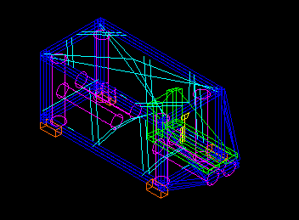
view 1
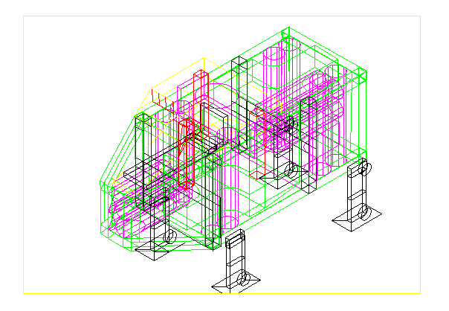
according to file autocad svsh18.dwg reviewed
Additional fuel and liquid air tank not précised and forbidden

Height of the vehicle retracted 3000 mm +450 mm for retracted landing fit
Total height of the vehicle retracted : 3500 mm
Maximal width without polish accessories : 2500 m
These dimensions will be verified for compatibility for civil road and sea transportation

The structure’s elements must support the engines forces : 3000 kgf’
To attach these elements together we have choosen elements like rectangular tubes

The rectangular tube have a width of 200 mm and a heighth of 200 mm.
The internal thickness is 10 mm

That gives a perpendicular surface of the rectangular tube of 8000 mm2 and a linear mass of 0.8* 2 kg/dm
The elements of rectangular tubes have a distance of 48 meters, with a respective mass of approximatively 768 kg ( x 1.25)

The inertial moment is approximatively : (0.1dm * 2 dm * 2/2 dm * 2/2 dm)*2 =
0.4 dm4

The main structure trellis is : 3000 kgf’/8000 mm2 = 0.375 kgf’/mm2

Support engines ‘H’ tubes thickness : 30 mm (security force 6000 kgf’/engine
Deduced constraint : 2.5 kgf/mm2)

Other components :
{-full tubes for :20mm x 20mm (aluminium) old data}
-Thickness of the covered elements : 1mm aluminium
-Thickness of glass : 10 mm
4) Operational performances

In rising : f = 30000 N * 4
M = 10520 kg
Cz = 1.5
S = 9 m2
Rho = 1.3 kg/m3

(30000 * 4 -10520 * 9.81) = 1.5 * 9 * 1.3 * sqr(v) /2
→ v = 27 m/s = 100 km/h

Horizontal at ground level :
F = 30000 N * 2
Cx = 1.3
S = 4 m2
Rho = 1.3 kg/m3

30000 * 2 = 1.3 * 4 *1.3 * sqr(v) /2
→ v = 133 m/s = 480 km/h

Rising at 400 km altitude : 30 min (see simulation)
Acceleration of orbital speed 7777 m/s : 25 min (see simulation)

Two missions exist that must be realised before the official public entry into service of the prototype :

1) flight of set into orbital at 28000 km/h (7777 m/s) :
2) atmospheric flight of 100 km

5) Pre-study of complete security

-1) not starting of one or more engines for unknown cause : staying on the ground
0) electricity of command of engines with default on 5 v, 9 v, 24 v ((or 110 v)) => redundancy of the electrical alimentation with batteries and power alimentation
1) No more fuel or liquid air : parachute of the whole SVSH or Rusal machine
2) complete failure of 1 engine in lift => slow down with the 2 opposite engines
3) Failure of one engines for movment :
=slow down to 50 meters altitude
=slow down and landing with reduced pitch with other engines
4) Breaking of one part of the structure: never happening other landing with the pilot
5) failure other equipments out of security consequences

6) Fire : exctinction of fire or parachutre if more error
7) failure piloting : according to pilot otherwise with personal ventral parachute
8) loss of tightness in high altitude : personnal safety of air reserve
9) loss of movement control : pilot capability with the redundancies

6) Environmental conditions see petit atlas de science moderne in french, russian and english
(172 pages) gratis public published
www.sitediversifie.org
For information : Tmaxi : 138°c (all conditions together)
Tmini : -220°c (all conditions together)
Pmaxi : 1100 mbar(all conditions together)
Pmini : 0.00 mbar (space)
Composition of atmospheric air
All whole worldwide weather conditions for the vehicle

7) Environmental pollution

few CO2 et de HO vapor due to engines combustion of hexane and liquid air

complete cleaning through photosynthesis on the natural ground

complementary very very few pollution possible :
CO due to too few air in the chamber
NOx due to too high temperature in the chambers

8) Piloting of Soucoupe Volante Spatiale Heyden

Preliminary :
Lift and down with 4 propulsion engines
Going on, going back and turning with 4 engines

Persons of SVSH : 1 pilot (1 little failure piloting for 1000 h of flight)
1 navigator and 1 for security redundancy engines

possible piloting: - manual with the pilot
- sequential by the navigator through a personnal computer
- commutation trough interface cards commanded by the pilot with preferred neutral manual piloting and with redundancy
Appendix 1 fuel and liquid air systems

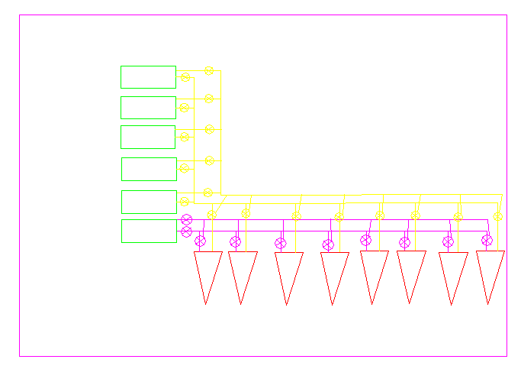
Appendix 2 : general schematic of the liquid air frigo system

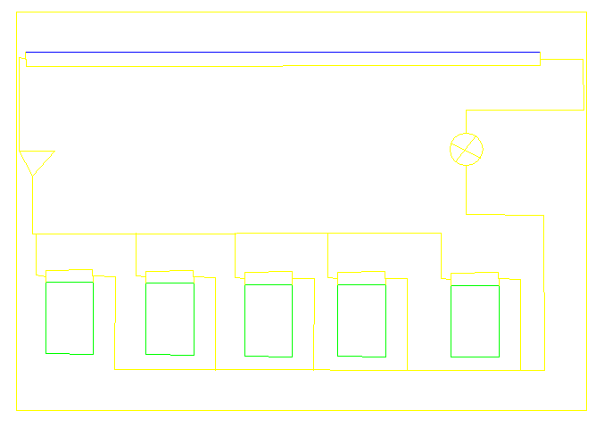

Appendix 3 : basic principle electrical system (preliminary)

Left part : Electrical main security : XCor Aerospace engines,
Thales engine’s manual commands
Siemens and AEG :automatic electronic Command

Right part : Electrical general : lamps, cockpit equipments comprising electrical power
alimentation, and other if necessary
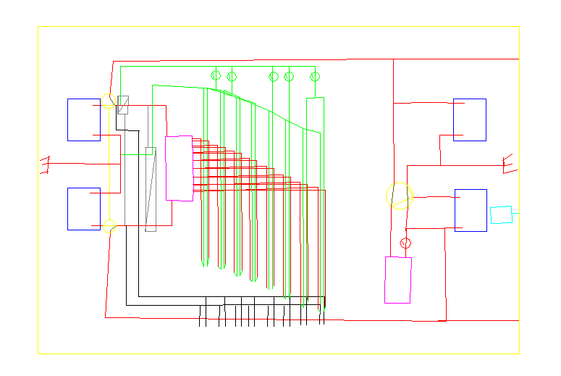

Appendix 4 : pressurisation system for the cockpit

